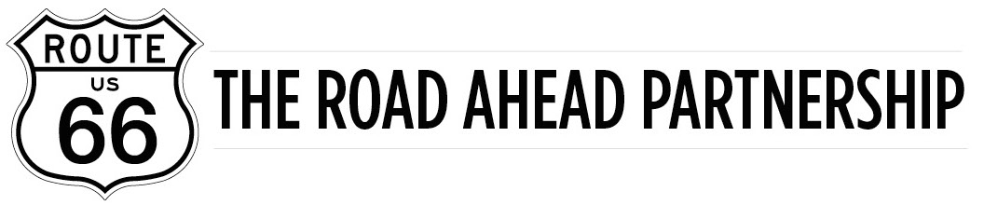
January 29, 2023
FOR IMMEDIATE RELEASE

Route 66 Road Ahead Partnership 4th Quarter ‘22 Report

The Route 66 Road Ahead Partnership Working Groups work throughout the year to meet goals and achieve outcomes to revitalize and sustain Route 66 as a national icon and international destination. Quarterly reports are submitted to the Board of Directors and published on the Road Ahead website, www.route66roadahead.org (by clicking on the “News” or “Resources” tabs). Some highlights of the 2022 4th Quarter Update Report follow.
The White House released news that President Biden intends to appoint members to the Route 66 Centennial Commission soon. Efforts to pass legislation to designate Route 66 a National Historic Trail before the end of the 117th Congress were not successful. The measure will be reintroduced in the 118th Congress and efforts will resume.
It was also sadly noted that longtime Route 66 friend and advocate, John Conoby [retired National Park Service], passed away in December 2022. Conoby worked tirelessly on the initiative to designate Route 66 a National Historic Trail. His expertise and friendship will be sorely missed.
Northern Arizona University (NAU) is offering teachers across the nation a professional development opportunity called “Racialized Spaces on Route 66” which uses the road as a foundation to develop curriculum materials embedded in social justice and foster critical thinking in K-12 students. The Route 66 Road Ahead Partnership’s Research and Education Working Group partnered with NAU in support of the program that has been awarded a grant from the National Endowment for the Humanities.
You can find more details and more updates in the full report available on the Route 66 Road Ahead Partnership website (www.route66roadahead.org).
Established in 2015, with the support of the National Park Service and the World Monuments' Fund, The Route 66 Road Ahead Partnership’s mission is to revitalize and sustain Route 66 as a national and international icon through partnerships focused on promotion, preservation, research and education, and economic development.
###
Contact:
Bill Thomas, Chairman
Route 66 Road Ahead Partnership
rt66theroadahead@gmail.com
217-648-5077

